.

**“FERTILIZERS”**

**INTRODUCTION:**

MACHINE LEARNING is the area of computational science that analyses and interprets patterns and structure in data and learns from it and enables decision making.

Machine Learning allows the user to feed a computer algorithm with data and then the computer analyzes and makes decisions based on the input it is trained with.

There are a lot of fields Machine Learning can be used and is being used. One such field is “Agricultural Sector”.

Sustainable agriculture is the farmer’s ability for producing food without affecting the environment as well as the surrounding eco system.

There are few problems that are related to agriculture, few of them are fertilizer usage, availability of artificial nutrients, crop growth, availability of sunlight, water and wind.

All these factors are equally important out of which fertilizer usage plays a vital role in proper growth of plant.

Fertilizers are the main reason for the proper growth of the plant at its initial stage. Nitrogen, Phosphorous, Potassium are the three main elements when it comes to fertilizers.

Nitrogen stands as the reason behind the proper growth of the leaf, whereas potassium aids in stem growth, movement of water in the plant, and also helps the plant in promotion of fruiting and flowering. Phosphorous in plants helps it to convert other nutrients into usable building blocks which helps it to grow.

For successful agriculture, we need to first be aware of the basics of different fertilizers, their usage and importance.

This Project “FERTILIZERS” helps to do agriculture in the most effective way possible.

Predicting the best fertilizers for the crop using Machine Learning can help improve agriculture to a greater extent. This project mainly concentrates on the use of best fertilizers and improving the growth rate of the plants.

The basic idea is to test the soil for nutrients and components present and then compute the fertilizer that best suits it using fertilization model.

**OBJECTIVES OF RESEARCH:**

The overall objective of this project is to predict the best fertilizer that can be used for a particular type of soil to help grow plants at an improved rate.

Below are the few specific objectives:

* To improve the growth of plants.
* To use the best fertilizer available.
* Considering temperature, humidity, moisture present in the soil to know which fertilizer can be used to get good yield.
* Also predicting the best fertilizer by considering the type of target soil.
* Determining the type of fertilizer to be used based on the crop that is to be grown and also on the composition of Nitrogen, Phosphorous and Potassium present in the target soil.

**PROBLEM STATEMENT:**

When it comes to fertilizers there are three main components a plant needs for its proper growth. They are Nitrogen, Phosphorous and Potassium.

The main objective behind this project is to produce best crops before it reaches the public. (Vision)

Agriculture now-a-days is being done in all possible ways using all kinds of fertilizers without being checked before its usage. If this problem is ignored, then it may be directed to improper growth of the plants. (Issue Statement)

Improper usage or selection of wrong fertilizer may affect the agriculture growth.(Farmers are the most effected persons due to this problem)

Choosing the best suitable fertilizer helps in reducing the effect on the plant growth.

Predict­­­­­­­ing­ the best suitable fertilizer for the effective plant growth by taking the parameters such as moisture, soil type, crop type etc. into consideration.

**INDUSTRY PROFILE:**

* Indian agriculture industry is at the verge of a revolution that will modernize the entire food chain in India and as the total food production.
* Size Of The Industry:

It contributes almost 18.5 % of India’s GDP.

* Agriculture is the primary source of livelihood for most of India’s population.
* It serves as the source of economy to a particular country.
* It plays a vital role in international trade market.
* The main source of livelihood for most of the people is agriculture. Almost 70% of the people directly rely on agriculture as a mean of living.
* India has the 10th largest arable land resources in the world with 20 agri-climatic regions. All 15 major climates in the world exist in India.

**REVIEW OF LITERATURE:**

There are many countries whose economy is dependent on agriculture. From employment generation to contribution to national income, agriculture plays a vital role. Agriculture is the backbone of economic system. Increasing population means there must be an increased focus on the agriculture sector as well.

Agriculture not only provides food and raw material but also employment opportunities to a very large proportion of population.

Agriculture serves as:

1. Source of livelihood
2. Contributes to National Income
3. Supply of food and fodder
4. Has importance in International Trade
5. Overall economic development
6. Source of government income

* Agriculture serves as the main source of economy to a country either in a small or big way.
* Therefore, this project deals with how to help farmers grow crops at an improved rate.
* Since, agriculture plays a crucial role in maintaining the economy of the country, this is a trial to help the farmers in their work so as to keep the level of agriculture protected.
* The main objective of this research is to help keep up the economy of our country without getting degraded.
* Almost 70% of our country’s population is directly dependent on the economy that we get through agriculture.
* This project helps the farmers to improve their crop yield by helping them choose the correct fertilizer to be used.
* The growth of plant requires many primary and secondary parameters like water, sunlight, wind, Temperature, Humidity, Moisture, Type of the soil it is grown, the composition of the elements present in the soil, fertilizers.
* Out of which the secondary parameter for the growth of the plants- Fertilizer plays a very important role.
* When it comes to fertilizers there are three main important elements that are to be checked for. They are Nitrogen, Phosphorous, Potassium.
* Firstly, the soil is to be checked the composition of the above mentioned elements.
* The type of fertilizers taken in this project are Urea, DAP,

14-35-14 , 28-28 , 17-17-17 , 20-20.

* Urea consists of 35 to 40 units of Nitrogen and 0 units of potassium and phosphorous.
* DAP consists of 12 to 15 units of Nitrogen and 35 to 40 units of phosphorous and 0 units of potassium.
* 14-35-14 consists of all the three elements and with composition of 7 to 10 for nitrogen and potassium, 25 to 30 for phosphorous.
* 28-28 consists of 20 -23 units of Nitrogen, 0 units of potassium and 15-20 units of phosphorous.
* 20-20 has 8-15 units of Nitrogen, 0 units of potassium and 10 units of phosphorous.
* 17-17-17 has 10-15 units of all the 3 elements.
* The temp range is btw 20-40, humidity(50-70), moisture(35-65).

**DATA COLLECTION:**

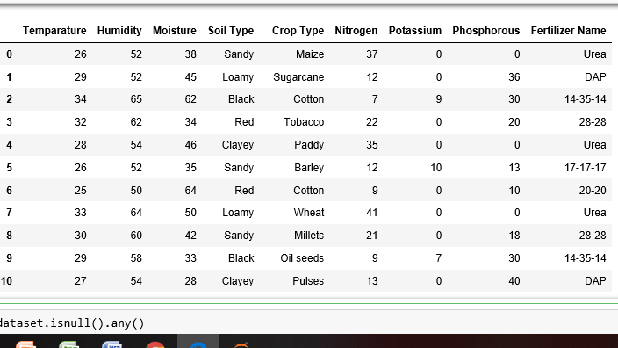

Figure – 1(Dataset)

* Various websites were referred to collect the proper dataset required to find out the name of the fertilizer to be used for the target soil.
* Secondary input parameters like temp, humidity, soil type, crop type etc are being used to predict the fertilizer that best suits the crop.
* The dataset shows the composition of Nitrogen, Potassium, Phosphorous that are the three main components in case of fertilizers.

**METHADOLOGY:**

Supervised Learning

Regression Classification

1. Linear Regression 1. Logistic Regression
2. Multilinear Regression 2. Naïve Bayes Classifier
3. Polynomial Regression 3. Decision Trees

4. Nearest Neighbour

5. Random Forest

Classification:

Algorithm used: K-Nearest Neighbor

The K- Nearest Neighbors algorithm is a classification algorithm and it is supervised. It takes a bunch of labelled points and uses them to learn how to label other points. To label a new point, it looks at the labelled points closest to that new point (those are its nearest neighbors ), and has those neighbors vote, so whichever label the most of the neighbors have is the label for the new point (the “k” is the number of labels it checks and it is an odd number )

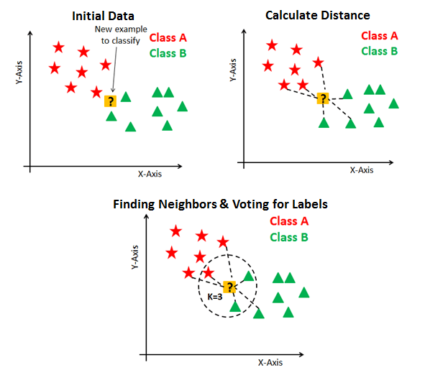

Figure - 2

**DATA PREPROCESSING:**

Figures and Tables:

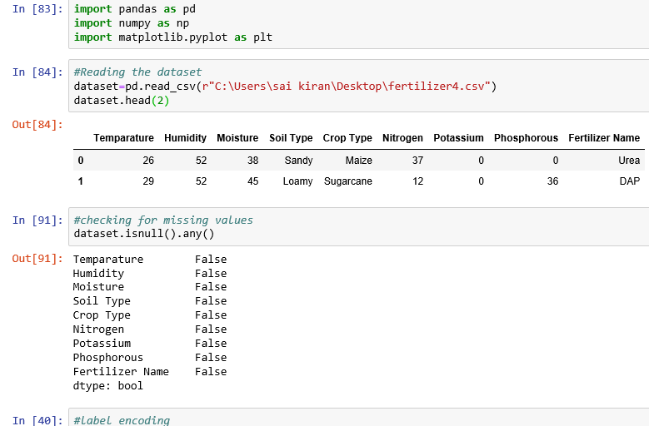

Figure – 3(a)

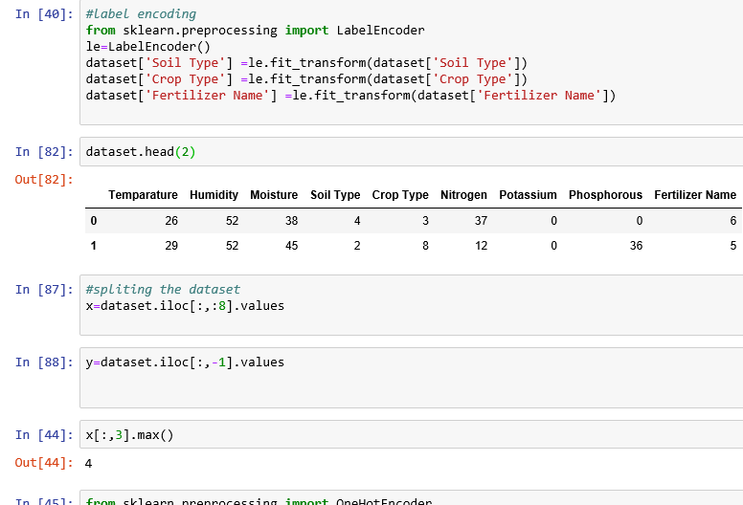

Figure – 3(b)

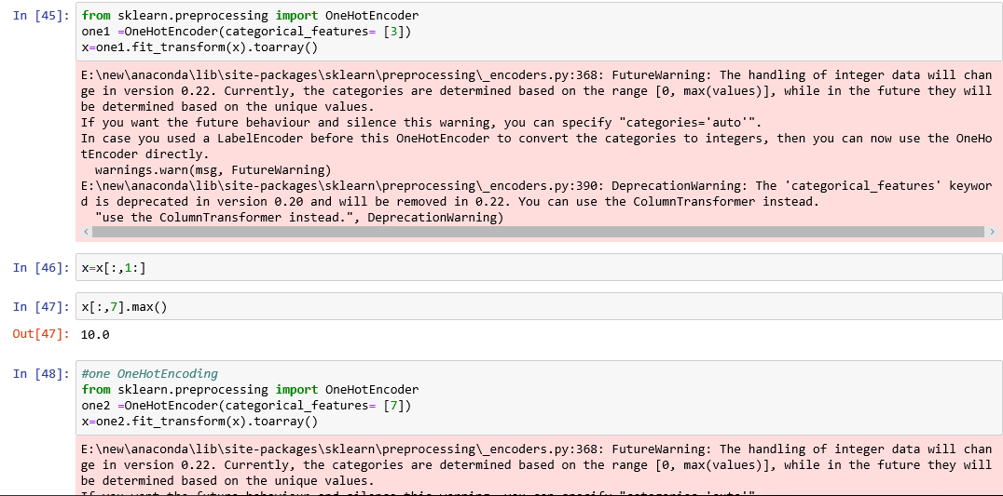

Figure – 3(c)

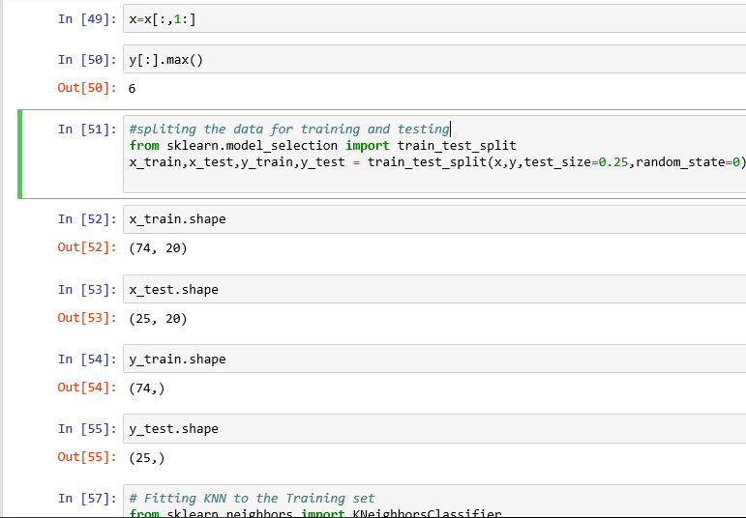

Figure – 3(d)

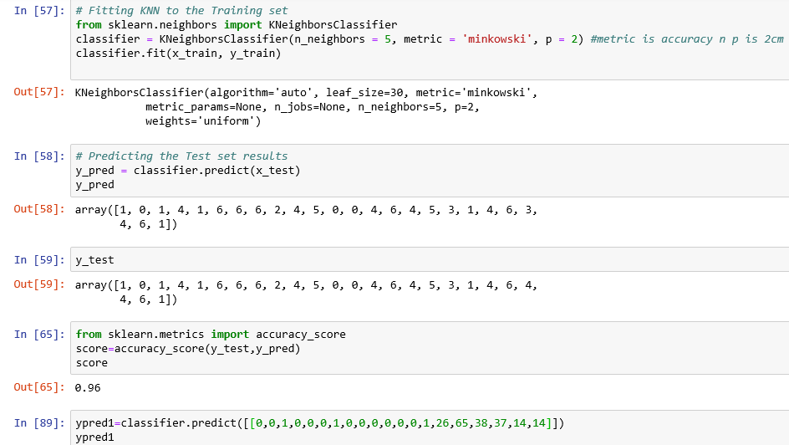

Figure – 3(e)

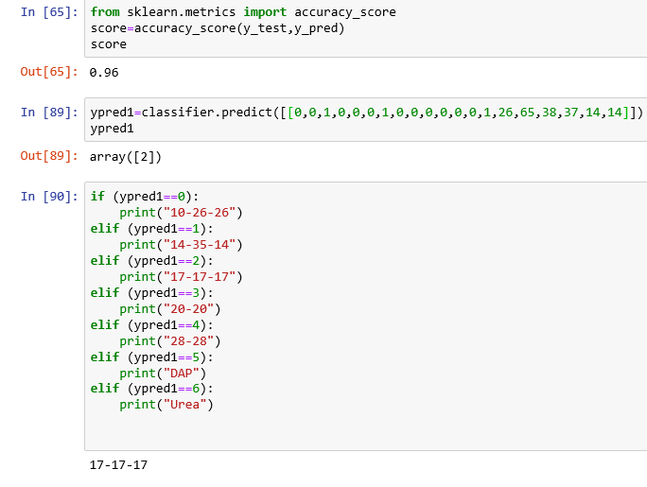

Figure – 3(f)

**ACCURACY:**

Naïve Bayes – 64%

Random Forest - 92%

K- Nearest Neighbor – 96%

Below are the graphs (Roc-Auc) that gives the accuracy of the model:

* Graph between y-pred[:,0] vs y-test[:,0]

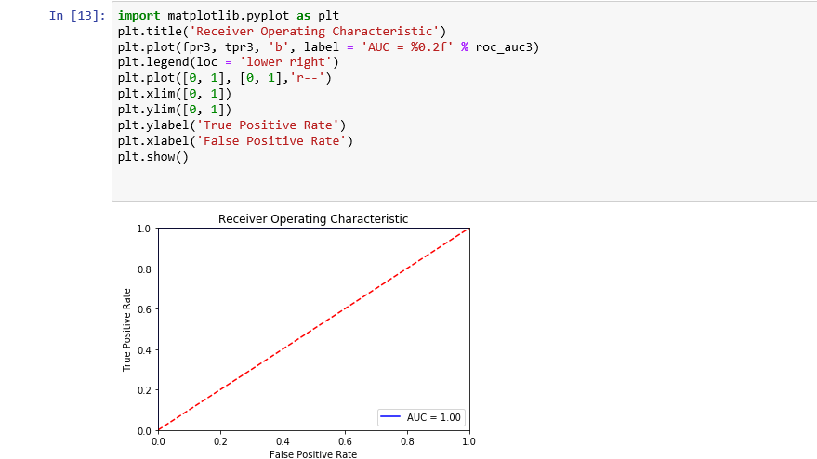

Figure – 4(a)

* Graph between y-pred[:,1] vs y-test[:,1]

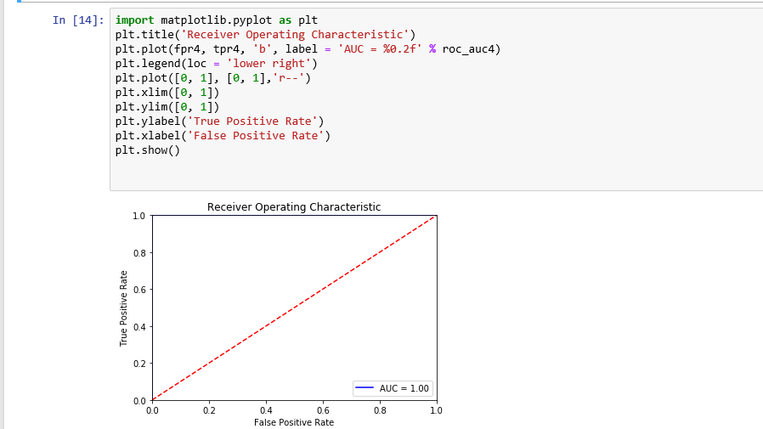

Figure – 4(b)

* Graph between y-pred[:,2] vs y-test[:,2]

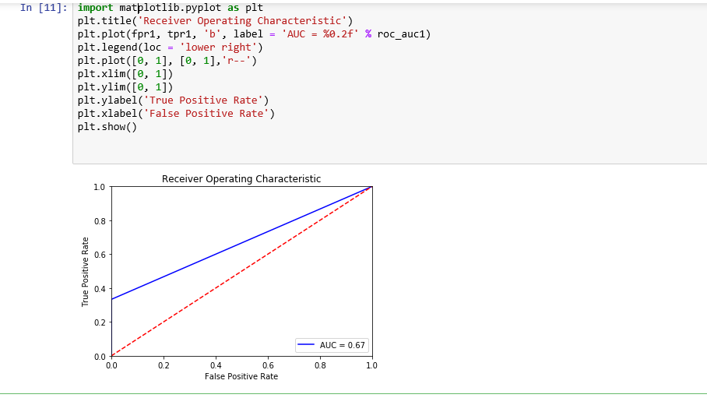

Figure – 4(c)

* Graph between y-pred[:,3] vs y-test[:,3]

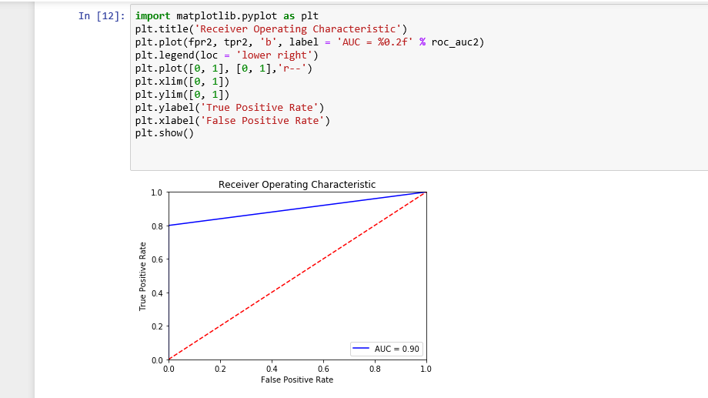

Figure – 4(d)

* Graph between y-pred[:,4] vs y-test[:,4]

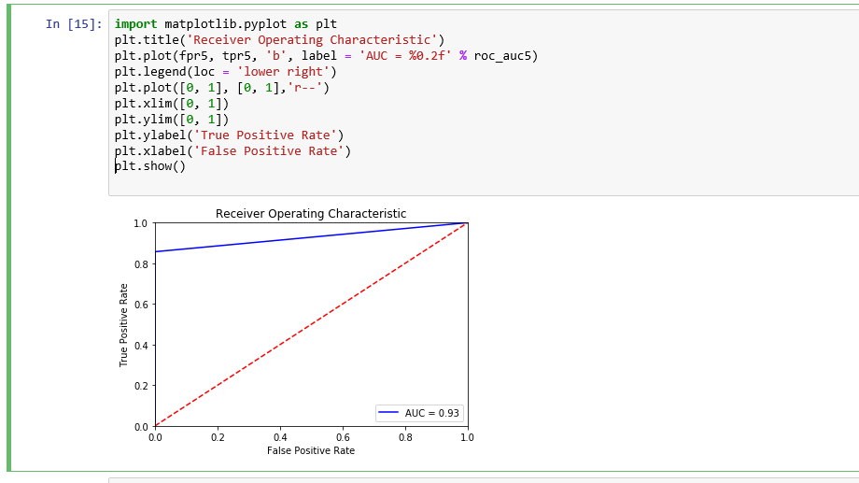

Figure – 4(e)

* Graph between y-pred[:,5] vs y-test[:,5]

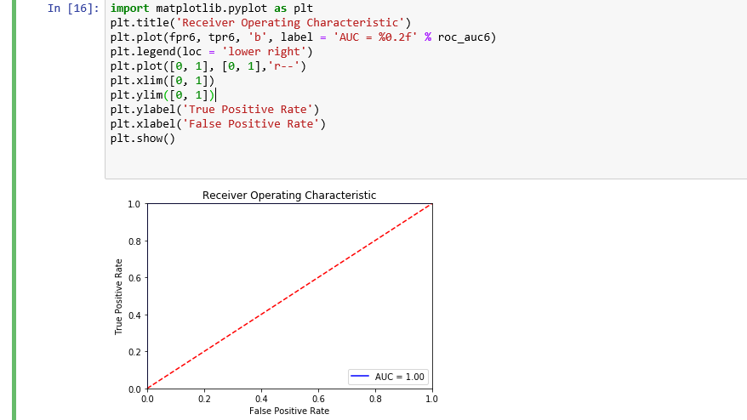

Figure – 4(f)**­­­­­**

* Graph between y-pred[:,6] vs y-test[:,6]

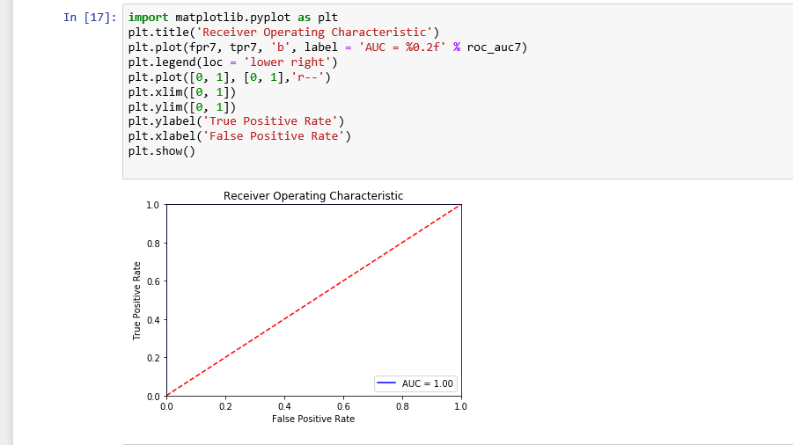

Figure – 4(g)

**Heat Map:**

Below is a graph that gives correlation among all the variables.

1. Temperature

2. Humidity

3. Moisture

4. Soil Type

5. Crop Type

6. Nitrogen

7. Potassium.

8. Phosphorous

9. Fertilizer Name

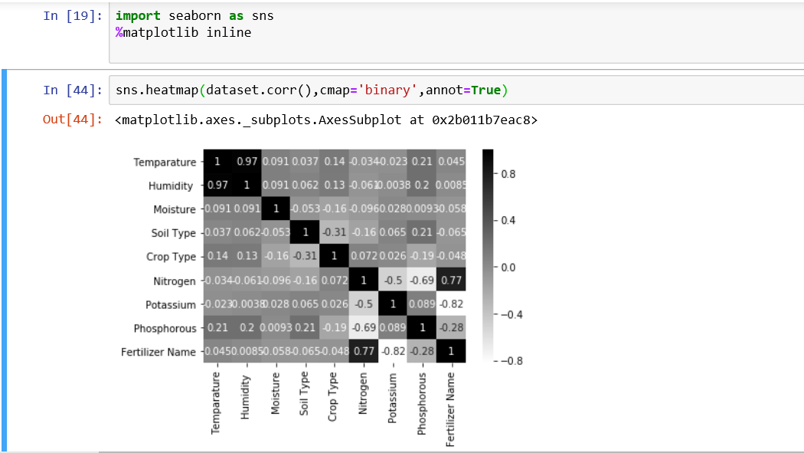

Figure - 5

**CONFUSION MATRIX:**

Confusion Matrix as the name suggests gives us a matrix as output and describes the complete performance of the model.

There are 4 important terms:

1. True Positives
2. True Negatives
3. False Positives
4. False Negatives

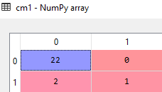

Figure – 6(a)

TP- The cases where the predicted value is Yes and also the actual value is Yes.

Therefore, TP=1

TN- The cases where the predicted value is No and also the actual value was No.

Therefore, TN=22

FP- The cases where the predicted value is Yes and the actual value was No. Therefore, FP= 0

FN- The cases where the predicted value is No and the actual value was Yes. Therefore, FN=2

Similarly, we have six other confusion matrices for this project:

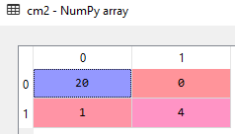 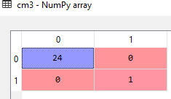

Figure – 6(b) Figure – 6(c)

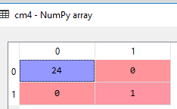 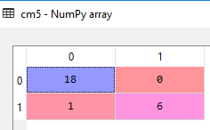

Figure – 6(d) Figure – 6(e)

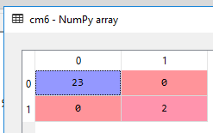 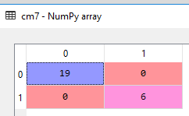

Figure – 6(f) Figure - 6(g)

To find accuracy of our model we need to plot ROC-AUC curve for which we calculate TPR(true positive rate) and FPR(false positive rate)

TPR is also called as recall or sensitivity.

TPR = TP/ TP+FN

TP – True Positive

FN – False Negative

Specificity = TN/ TN+FP

FPR( False Positive Rate) = 1- Specificity

**FINDINGS AND SUGGESTIONS:**

* To maximize the proper growth of plant selection of appropriate fertilizer that is to be used plays a vital role.
* This depends on various factors like Temperature, Humidity, Target Soil, Crop type etc.,
* Various algorithms like Naïve Bayes, Random Forest, K- Nearest Neighbor were checked.
* Out of which K- Nearest Neighbor was found to have the maximum accuracy and was implemented.
* Being able to find out the fertilizer that best suits a particular type of soil and crop to be grown helps farmers get high yield of crops.
* The composition of Nitrogen, Phosphorous, Potassium is checked before selecting a fertilizer as these elements play a very important role in the plant growth.
* Fertilizers play a vital role in growing the crops at an increased rate.
* Therefore, helping farmers in selection of the best fertilizers for their soil and crop type increases the economy.

**CONCLUSION:**

Selecting a perfect fertilizer is still a challenging situation for the farmers. The main goal behind this project is to help farmers in getting a good yield of crops by helping them predict a fertilizer that best suits their soil type.

Fertilizers play a vital role in deciding the fate of the farmers. They must be chosen in a way that they help the farmers and not in a way that they become the root cause for destruction.

We hear to a lot of news saying that a farmer killed himself…, a farmers killed his family along with him…, a farmer gone into depression and what not…, the main reason behind all this is not being able to decide what crop is to be grown in what kind of soil using which fertilizer.

Agriculture is the main source of economy for most of the countries including India. Almost 70% of India’s population is directly depending on agriculture for their living.

So, it is our responsibility that we maintain the economy of our country at its maximum rate.